Magnepan 3.7i planar magnetic/ribbon and DWM woofer loudspeaker system
- REVIEW
- Chris Martens
- Oct 03, 2014
- A
- A
- A
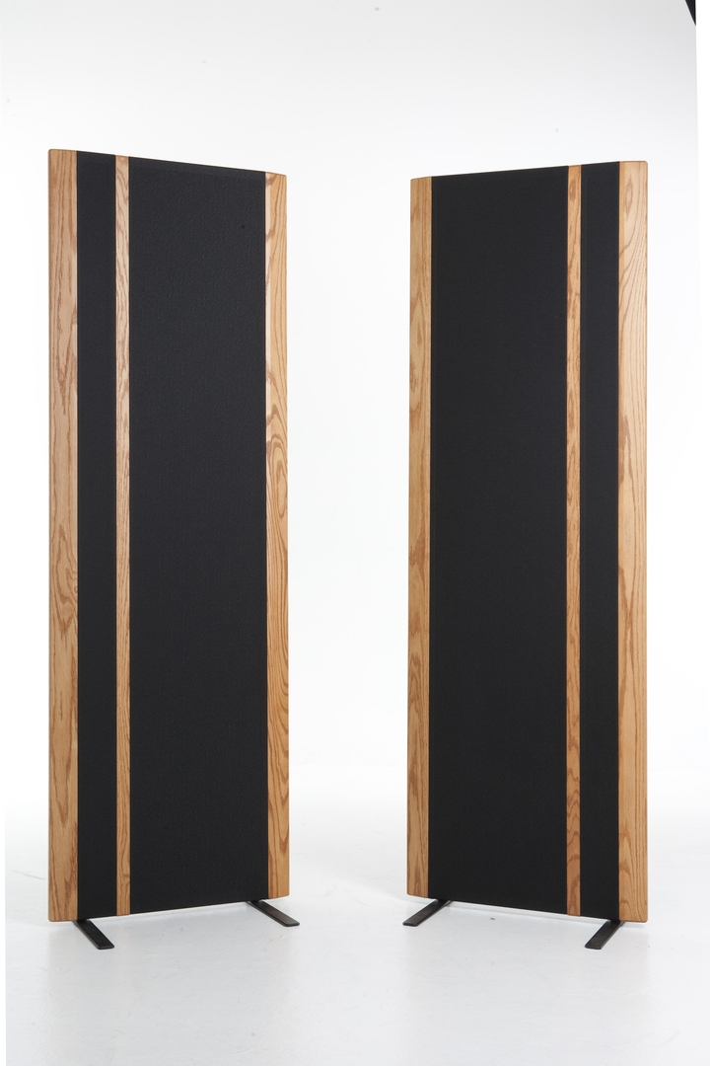
Founded in 1969, Magnepan is a Minnesota-based maker of critically acclaimed, high value dipole loudspeakers that are based upon planar magnetic and ribbon-type drivers (technical areas where company founder Jim Winey holds a number of core patents). Although Jim Winey retired some years ago, Magnepan is today lead by his son, Mark Winey, who works in concert with veteran marketing manager Wendell Diller to continue research and development efforts that help the company maintain (and extend) its technological edge. Not surprisingly, Magnepan loudspeakers continue to get better over time.
In recent years Magnepan research has led to a revamp of the firm’s entire product line, resulting in the introduction of a number of new models along with substantial revisions to acknowledged classics. For this review, we will focus on one of Magnepan’s most recently updated designs: the next-to-the-top-of the line 3.7i ($5,995 or £6,500 per pair). In passing, we will also take a look at the firm’s optional DWM planar magnetic woofers ($795 or £950 each), since we can envision applications where 3.7i owners might need or want to add one or two DWMs to their systems in order to tap their full performance potential.
Magnepan’s 3.7i is a roughly 6-foot tall, 2-foot wide, and 1.625-inch thick hybrid planar magnetic/ribbon driver-equipped, dipole loudspeaker. The perimeter frame of the speaker is CNC milled from a slab of MDF material, with large, elongated, rectangular openings for the planar magnetic and ribbon drivers, plus a small opening toward the bottom where the crossover network and speaker terminal panel are housed. Once assembled and tested, the entire speaker is wrapped in sonically transparent grille fabric, trimmed with either wood or aluminium accent panels, and then shipped with beefy pairs of bolt-on steel feet (each shaped like an inverted letter ‘T’, when viewed from the side).
The heart of the 3.7i is its sizable quasi-ribbon-type planar magnetic bass/midrange driver, which consists of a sturdy perforated metal screen in the rear, arrays of precisely spaced vertical bar magnets affixed to the front of the screen, and a very thin Mylar diaphragm suspended in front of the magnet array. Bonded to the diaphragm is an elongated, serpentine ‘voice coil’ made of thin, light, ribbon-like aluminium conductor strips covering nearly the entire surface of the diaphragm. As audio signals pass through the conductors, the diaphragm membrane is attracted to or repelled from the magnet array, thus producing sound. The one-piece driver panel is internally divided into side-by-side bass and midrange sections, each optimised for its respective frequency range. Magnepan uses various proprietary techniques to control unwanted resonance both in the driver diaphragm and in the perforated screen/magnet assembly.

Adjacent to the bass/midrange panel is Magnepan’s signature ribbon tweeter—the same one used in the flagship 20.7 loudspeaker. Unlike the compact ribbon tweeters sometimes used in piston-type loudspeakers, Magnepan’s ribbon tweeter features an ultra-thin aluminium foil ribbon approximately ¼-inch wide and five feet long. Many audiophiles regard this tweeter as one of the finest high-frequency transducers in the world and I count myself in that group; it offers smooth and beautifully extended highs and astonishingly quick and nuanced handling of treble transients and textures.
Magnepan offers few details on the crossover of the 3.7i, but on the basis of talks with Winey and Diller I gather a time/phase coherent network is used. The rear panel of the speaker is interesting, too, because it provides not only the expected ‘+/-‘ speaker terminals, but also two sets of connection points where, at the user’s option, midrange and tweeter loading resistors (included) or bypass jumpers can be installed. In this way, Magnepan enables users to trim the speaker’s midrange and treble output to best match the acoustics of their rooms.
3.7i’s are supplied as a mirror-image pair, which gives listeners the option to orient the speakers with the tweeters positioned inwards or outwards. Magnepan says the former arrangement yields tighter and more precisely focused imaging, while the latter produces wider, deeper, and more spacious soundstages. Rather than going by those rules of thumb, however, I would suggest that owners try both orientations, since in my practical experience it often happens that one arrangement or the other will yield markedly superior results in any given room.
What makes the 3.7i different from the 3.7? Frustratingly, Magnepan has declined to discuss the specific technical changes made, arguing instead that the best way to evaluate the changes is not by reading a technical paper, but rather by listening to the speaker in action and then drawing one’s own conclusions. (Actually, Magnepan did share some details on the 3.7-to-3.7i upgrade, but only on the condition that I not publish them; I could tell you, but I’d have to kill you – and myself – afterward). Like many, I would like to have complete information on the changes, but I can also respect Magnepan’s contention that meaningful assessments should be based, first and foremost, on careful, critical listening.
In daily use, the 3.7i offers a number of compelling sonic virtues, some of which are carried forward from the already excellent 3.7 and some that are distinctive to the 3.7i. Let’s begin by reviewing some of the speaker’s acknowledged strengths.
Like its predecessor, the 3.7i is one of relatively few dipole speakers to offer legitimate, near full-range frequency response, with bass extending (at least in some rooms) down into the mid-30Hz region and with highs reaching upward beyond audibility. In contrast, many would-be full-range dipoles turn out not to deliver the bass power and depth the 3.7i has on offer (e.g., Quad electrostatic designs) or alternatively wind up being huge and expensive (e.g., the superb but very large Sound Lab electrostatic designs). The 3.7i, on the other hand, stands as a well-balanced and well-rounded ‘do-all’ speaker—one that offers an elusive mix of sonic detail, transparency, wide-range frequency response, and freedom from box-speaker colourations—all at a reasonable price.
Next, the 3.7i—like the 3.7 before it—serves up unusually broad and deep soundstages that also expand in the vertical dimension to achieve an exceptional degree of realism. One of the more pleasurable characteristics of live music is the sensation of waves of sound sweeping up and over you to fill the space—a sensation that many piston-type loudspeakers have difficulty reproducing. In contrast, it is easy for the nearly 6-foot tall 3.7i to re-create the sensation of soundstage height, in the process capturing much of the sweep, flow, and sheer scale of live music.
To experience what I mean by the terms sweep, flow, and scale, try listening to Revueltas’ Sensemayá as captured on Chicago Symphony Orchestra Brass Live [CSO-Resound, SACD], which presents a big, powerful, hall-filling sound as appropriate to the material at hand. Through many speakers, the soundstage on this track can become truncated to the point where it simply seems too small to do justice to the composition. Through the 3.7i, however, the soundstages expand to fit the requirements of the music – faithfully conveying the sense of listening in a large, acoustically correct orchestra hall. In short, the 3.7i routinely transports listeners to large, expansive, and quite believable sound spaces – where not many competing speakers can take you.
Third, like other Magnepans before it, the 3.7i demonstrates uncanny qualities of coherence and cut-from-whole-cloth sonic integrity—qualities that become particularly apparent when listing to instruments whose voices span several octaves in range. As pitches rise and fall, from the highest notes you can hear all the way down to the lowest notes the speaker can reproduce, there is never any sense of transitioning from one disparate type of driver to another. I think this is directly attributable to the fact that the 3.7i drivers are not only well-matched in terms of voicing, but also offer identical dipolar radiation patterns. As a result, there is never any sense of disparate driver types loading the room in fundamentally different ways, causing subtle sonic discontinuities in the process.
As I listened carefully to the 3.7i, my assessment was that it not only preserved but actually expanded upon the 3.7’s overall coherency. If you heard the original 3.7 in isolation you would rightly think it to be a very fine loudspeaker, but if you then switched to the 3.7i you would soon realise that, from the heart of the midrange and on up into the upper midrange, the new speaker sounds noticeably smoother and more at ease with itself. Moreover, levels of internal ‘self-noise’ seem to be reduced in the 3.7i, so that backgrounds become quieter, making it easier for low-level details to be revealed.
To hear these qualities in action, listen to the track ‘Big Brother’ from Jen Chapin’s reVisions [Chesky SACD], which is a brilliant jazz trio’s update on a selection of classic songs from Stevie Wonder. Listen, for example, to the feisty, provocative edge in Chapin’s voice as she sings a line accusing politicians of only visiting their constituents “…around election time.” The 3.7i’s really bring Chapin’s voice, with its many tonal colours, emotional moods, and engaging inflections, vividly to life. Note, too, the fascinating passage near the end of the song where saxophonist Chris Cheek takes a walk from the front left side of the stage to the rear as he continues to play. As Cheek turns and moves, the Magnepans capture small spatial details that help you know where Cheek is standing and which way he is facing as he moves. While many speakers do a good job with this track, the 3.7i does a great one.
The 3.7i also differs from the original 3.7 by offering noticeably more expressive and expansive dynamics. The 3.7i, like most Magnepan speakers, is relatively power hungry and low in rated sensitivity, but give the speaker the power it needs and it will respond with impressive energy and grace—areas where the 3.7i clearly outperforms the original 3.7. When pushed hard by challenging musical material the earlier speaker could eventually start to exhibit faint traces of strain in the form of a subtle, hard-edged or even ragged-sounding quality. In contrast, when you lean hard on the 3.7i it simply plays more loudly, always maintaining a smooth-tempered sonic disposition.
To appreciate what I mean, listen to John Adler’s Confronting Inertia [Origin Classical], where Adler explores both the pensive and more fiercely forceful voices of his trumpet. On the more delicate end of the dynamic spectrum the 3.7i captures the subtleties of Adler’s horn with admirable finesse, but as Adler probes the other end of the dynamic envelope the 3.7i answers with its own unflustered yet decidedly muscular response—delivering acoustic power tempered with an easy-going kind of grace. I won’t tell you the 3.7i can compete with horn-type speakers in terms of dynamic clout because that would be ridiculous, but I will tell you that it produces a much bigger, more forceful, and yet more relaxed presentation than the 3.7 did.
Good though the 3.7 was and is, there is something audibly and inarguably more ‘right’ about the new 3.7i. Interestingly, from a musical perspective, the new design at once sounds more revealing of low-level textures and details, yet also smoother and less prone to edginess (a package of virtues that don’t often travel together in most speakers).
Are there any caveats? There are a few, but none of them major. First, the 3.7i requires an amplifier that offers substantial power output and the ability to deliver current into low impedance (4 Ohm) loads. Second, the Maggies need room in which to operate, as they should be positioned several feet out from the rear walls of listener’s rooms. For this reason, the 3.7i would not be ideal for smaller spaces. Third, note that the 3.7i’s low-end response will be adequate in many spaces, but not in all. Should your room prove problematic in this way, note that Magnepan’s optional DWM woofer panels (see the sidebar below) can work wonders. Finally, be aware that the 3.7i typically does not produce the pinpoint-precise images or razor-sharp sense of focus one might enjoy from speakers such as the excellent (but far more costly) Raidho D-1 monitors.
Magnepan DWM woofer panel
Listeners familiar with dipole speakers might agree that they can be tricky to position and that not all rooms seem amenable to supporting dipole bass. Recognising this potential problem Magnepan has created the DWM panel—a small, relatively light, deceptively high-output dipole woofer that can be used singly or in pairs to supplement the bass output of any of Magnepan’s speakers. Unlike the 3.7i itself, the DWM uses a double-sided magnet structure (that is, with opposing front/back magnet arrays) whose design is derived from the bass/midrange panel used in the firm’s flagship 20.7 loudspeaker.

DWMs are designed with dual, interlaced sets of ‘voice coils’ so that the DWM can be run either as a two-channel or single-channel woofer. When measured in isolation, the DWM’s bass extends only to about 40Hz, but when coupled with larger Magnepans an interesting phenomenon occurs; specifically, the low-frequency outputs of the DWM and of the main speaker couple with and reinforce one another such that bass response extends considerably lower than either unit used individually. Just as importantly, the DWM is perfectly voice-matched to the larger Magnepans and is likewise a dipole radiator.
I wound up using two DWMs with our 3.7i’s, using beefy Magnepan-supplied 1400 mH inductors to roll-off unwanted and unnecessary mid-bass, while taking advantage of the extra low-bass power and extension the DWMs provided. The results were well and truly spectacular, yielding very low-frequency (think mid-20Hz) weight and authority, yet without muddying the inherently transparent sound of the 3.7i in any way.

To my way of thinking, the 3.7i is easily one of the greatest performers I’ve yet heard in its price class—in large part because it does so many things right and so few things wrong. True, the 3.7i needs quite a bit of space and a lot of power to give of its best, but meet those requirements and the Maggies will serve up the sorts of rich, rare, and refined listening experiences typically associated with loudspeakers several times their price.
Technical Specifications
Magnepan 3.7i loudspeaker
Type: Hybrid planar magnetic/ribbon driver equipped dipolar loudspeaker (featuring a quasi-ribbon type bass/midrange driver and a true ribbon tweeter)
Driver complement: one quasi-ribbon planar magnetic bass/midrange panel-type driver, one true ribbon tweeter.
Frequency response: 35Hz – 40kHz
Impedance: 4 Ohms
Sensitivity: 86dB/2.83v
Dimensions (H x W x D): 1803 x 610 x 41mm

